Angular Assignment 3

**Q1:**

class ArithmaticAss3_1 {

No1: number;

No2: number;

Result: number = 0;

constructor(X: number, Y: number) {

this.No1 = X;

this.No2 = Y;

}

Addition(): number {

this.Result = this.No1 + this.No2;

return this.Result;

}

Substraction(): number {

this.Result = this.No1 - this.No2;

return this.Result;

}

Multiplication(): number {

this.Result = this.No1 * this.No2;

return this.Result;

}

Division(): number {

this.Result = this.No1 / this.No2;

return this.Result;

}

}

console.log("Object 1 Outputs ");

var objA1 = new ArithmaticAss3_1(20, 5);

console.log("Addition is :" + objA1.Addition());

console.log("Substraction is :" + objA1.Substraction());

console.log("Multiplication is :" + objA1.Multiplication());

console.log("Division is :" + objA1.Division());

console.log("\nObject 2 Outputs ");

var objA2 = new ArithmaticAss3_1(5, 5);

console.log("Addition is :" + objA2.Addition());

console.log("Substraction is :" + objA2.Substraction());

console.log("Multiplication is :" + objA2.Multiplication());

console.log("Division is :" + objA2.Division());

Output:

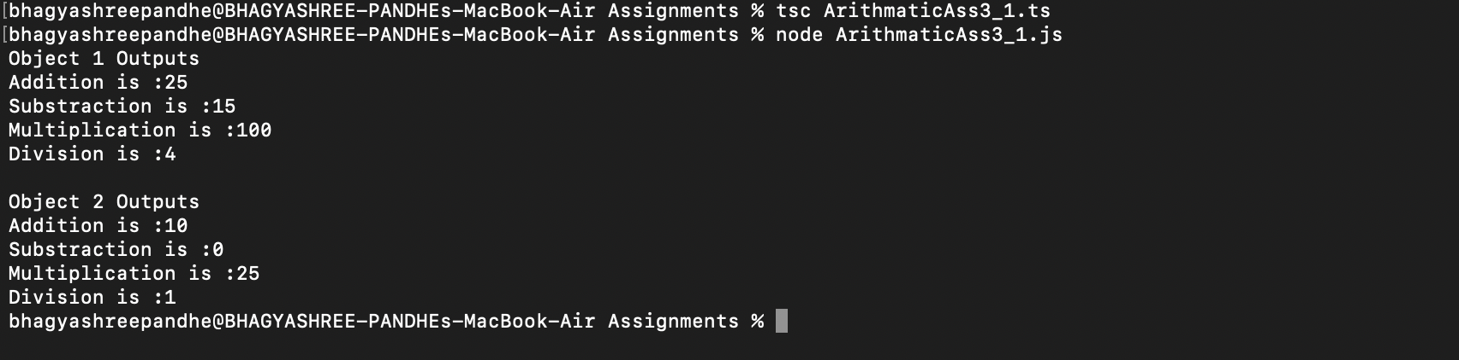

**Question 2:**

class Circle {

Radius: number;

PI: number;

constructor(*Rad*: number) {

this.Radius = Rad;

this.PI = 3.14;

}

Area(): number {

return this.PI * this.Radius * this.Radius;

}

}

console.log("Object 1 Outputs ");

var objCircle1 = new Circle(20);

console.log("Area of Circle is : " + objCircle1.Area());

console.log("Object 2 Outputs ");

var objCircle2 = new Circle(5);

console.log("Area of Circle is : " + objCircle2.Area());

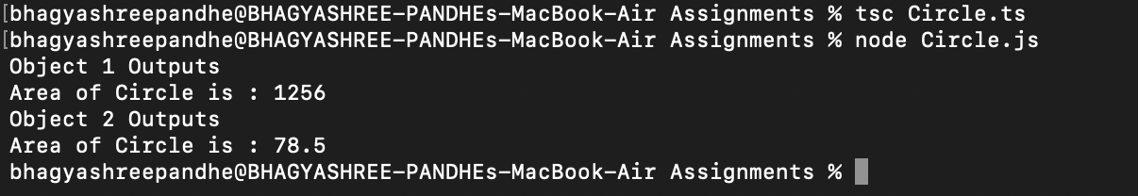

**Question 3:**

class Circle {

Radius: number;

PI: number;

constructor(*Rad*: number) {

this.Radius = Rad;

this.PI = 3.14;

}

Area(): number {

return this.PI * this.Radius * this.Radius;

}

}

class CircleX extends Circle {

PI: number = 3.14;

constructor(*radius*: number) {

super(radius);

}

Circumference(): number {

return 2 * this.PI * this.Radius;

}

}

console.log("Object 1 Outputs ");

var objCircleX1 = new CircleX(20);

console.log("Circumference of Circle is : " + objCircleX1.Circumference());

console.log("Object 2 Outputs ");

var objCircleX2 = new CircleX(5);

console.log("Circumference of Circle is : " + objCircleX2.Circumference());

